**SmartSQL**

**Requirements Document**

**160596K**

**System requirements**

The main requirement of the system is converting natural language into mysql query. So here, many use cases has been created such as create user, upload profile photo, change user information, upload new schema, delete schema, show tables and columns,convert natural language query, create review and view reviews

given below is the use case diagram for the system

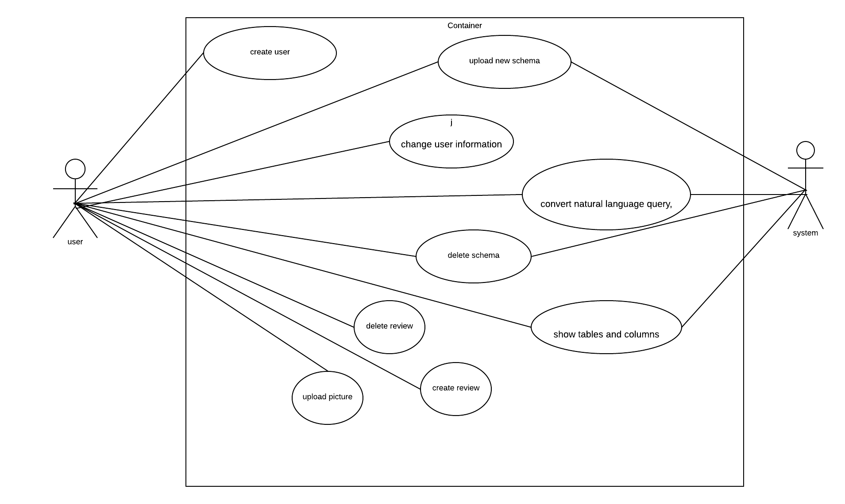

when a user create the account it will go to the account page of the user. In the left hand side of the account page, user can change the username or password and also can upload a profile picture. In the right corner, there is a small drop down menu which consists review creation and upload schema. When user clicks upload schema it will redirect to new page and there is a space for uploading schema. User can upload the schema there.

If the user upload the schema then user wants to click the submit button to confirm. After the confirmation it will redirect to account page and there will be a schema. User can clicks the schema and it will show up the tables and columns. Now, user can type natural language query in given box. After the submission, it will display the result. User can also review the product as well user can view other reviews.

**non functional requirements**

**Usability**

Friendly and attractive user interface

Users should have a nice experience when interacting with the system. The Icons, phrases of the system easily understandable. Average user takes 20 minutes to familiar with application.

**Reliability**

The system availability is important. System works on online but it will take some time for dumped

database to preprocess. So, availability depends on user’s internet connection. Mean time between failures will be around 1 or 2 years. If the MTBF is high, then loss of model data will

be problematic. Mean time to repair can be maximum of 2 days. The accuracy of the system depends on the accuracy of the modal. Usually the accuracy will be above 80%. response time of the system is less than millisecond when user has good internet connection.

**Security**

Users are authenticated using password so security is not an issue. user’s database schema kept secret in the server as far as possible. This is a GUI application so it should work on anywhere with an internet connection. System is very adaptability. There is no need for the configuration in this system. The user can simply visit the website to start his work.